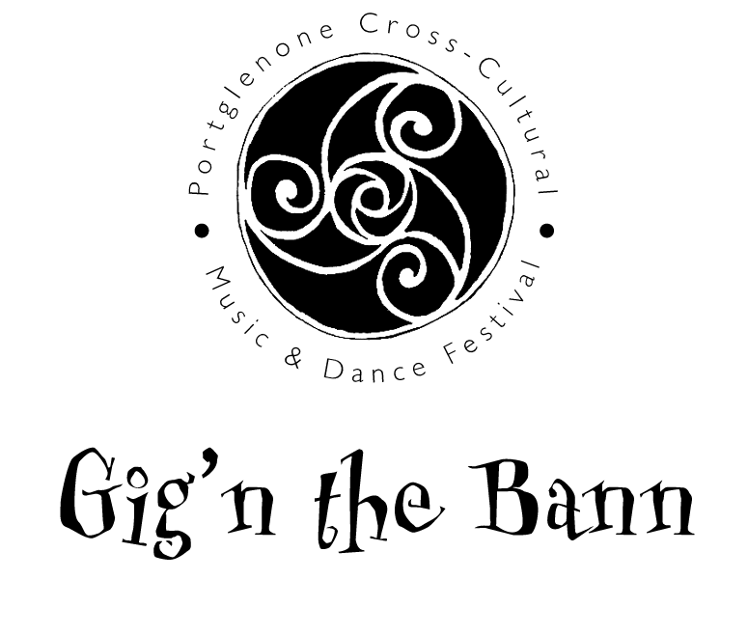
presents

Young Musician of the Bann 2011

- Six finalists will be selected by the competition committee and invited to perform in a live final at the Gig’n the Bann Festival, held in Portglenone on 4th September 2011.

- Things taken into consideration will be:
  - Musicality
  - Quality of performance
  - Presentation – the performer should treat the competition as a mini-gig. Sets should be introduced with a brief background into the tunes.
  - Each competitor may have up to two accompanists backing them (e.g. guitar/drums, bodhran/piano etc), and the sets should be arranged accordingly.

- Competitor should have three sets of tunes arranged for performance and the overall performance of the music should take no more than 12/15mins.

- Below is the genres of music eligible for the competition:

  - Irish traditional
  - Folk
  - Ulster Scots
  - Piping
  - Gospel

- To enter:
Fill out the form attached and send, along with a recording of yourself playing to the address at the bottom of the form. This can be a CD, tape, Youtube video etc..

Entries must be completed and received on or before 30th June 2011.
Finalists will be notified on or before 31st July 2011.

For further information an email can be sent to
ryan391@hotmail.com
Young Musician of the Bann
COMPETITION ENTRY FORM
(Competitors must be between 16 and 25 inclusive on 1st September 2011)

Live Final will be held on
Sunday 4th September 2011
In THE WILD DUCK – RIVERSIDE SUITE

PRIZES: 1st £300 plus a paid gig at Gig’n the Bann 2012
2nd £200
3rd £100

Please fill out this form and post with a recording of yourself

Name: _________________________________________
Address: _________________________________________

Contact Number: _________________________________________
Email: _________________________________________
DOB: _________________________________________

Post your entry to:

Ryan Graham
39 Townhill Road
Portglenone
Co. Antrim
BT44 8AD

Or email to ryan391@hotmail.com

